Kiran Girish

Period 4

05/02/16

Distance: 86605.98732899748

For 15 trials, I first untangle the list and then swap until I find a local minimum.

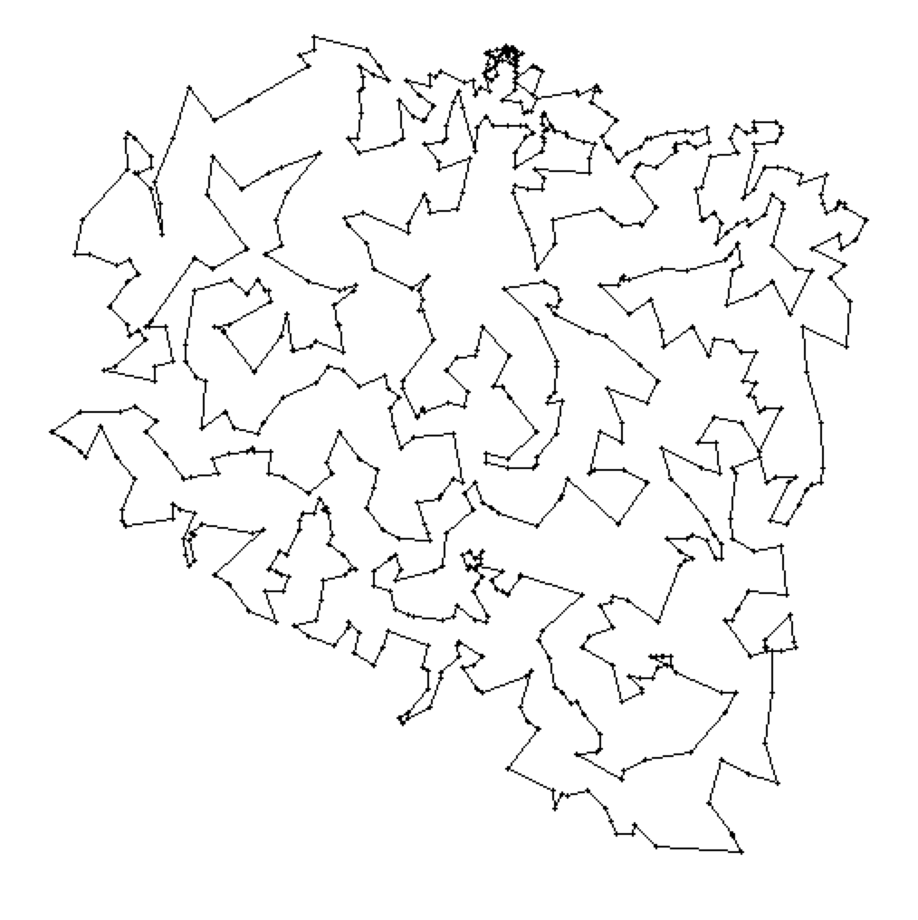

[1, 2, 7, 5, 4, 8, 10, 15, 12, 13, 9, 14, 20, 29, 31, 38, 60, 55, 42, 49, 62, 65, 71, 90, 89, 70, 57, 52, 37, 33, 30, 32, 35, 48, 59, 61, 88, 97, 82, 64, 78, 96, 103, 99, 87, 94, 101, 106, 122, 138, 146, 153, 154, 174, 183, 194, 219, 223, 225, 232, 218, 217, 211, 202, 173, 177, 152, 148, 145, 141, 129, 128, 102, 116, 136, 144, 201, 198, 206, 197, 193, 185, 164, 158, 172, 188, 216, 222, 228, 214, 204, 210, 221, 249, 279, 309, 278, 285, 293, 297, 302, 318, 319, 327, 315, 303, 282, 250, 254, 258, 275, 283, 286, 290, 287, 288, 259, 255, 238, 260, 273, 304, 276, 264, 241, 226, 203, 189, 186, 199, 207, 230, 233, 235, 251, 243, 300, 298, 291, 310, 323, 334, 341, 355, 344, 359, 363, 347, 333, 311, 299, 308, 320, 307, 350, 354, 367, 382, 427, 444, 425, 445, 428, 429, 420, 404, 399, 394, 391, 356, 389, 409, 376, 377, 380, 383, 373, 406, 405, 417, 431, 437, 433, 430, 441, 469, 474, 496, 528, 568, 554, 547, 532, 566, 524, 471, 456, 466, 407, 396, 397, 398, 366, 362, 349, 358, 361, 385, 393, 388, 403, 415, 440, 452, 464, 461, 468, 467, 495, 549, 593, 608, 594, 565, 553, 546, 545, 531, 482, 516, 540, 595, 667, 634, 652, 692, 712, 723, 734, 724, 694, 675, 683, 693, 679, 668, 661, 641, 603, 596, 569, 582, 597, 653, 639, 635, 636, 648, 656, 676, 670, 684, 680, 689, 673, 677, 657, 669, 660, 681, 674, 682, 698, 690, 686, 699, 711, 716, 722, 725, 726, 727, 732, 733, 729, 728, 730, 731, 718, 719, 720, 721, 715, 709, 708, 705, 704, 710, 713, 717, 714, 707, 706, 700, 703, 702, 701, 695, 696, 688, 685, 678, 697, 691, 687, 658, 672, 666, 654, 651, 644, 645, 646, 655, 663, 659, 671, 665, 664, 650, 642, 637, 607, 577, 581, 562, 571, 578, 600, 601, 611, 617, 612, 621, 590, 580, 589, 584, 579, 575, 557, 560, 556, 542, 514, 489, 492, 488, 503, 511, 497, 478, 458, 475, 486, 507, 530, 538, 533, 534, 541, 552, 548, 564, 586, 588, 604, 610, 616, 624, 643, 640, 631, 619, 615, 606, 599, 592, 573, 555, 570, 605, 609, 629, 628, 627, 625, 638, 620, 574, 647, 662, 649, 626, 598, 587, 583, 561, 550, 563, 529, 510, 506, 521, 525, 491, 484, 505, 502, 487, 477, 457, 434, 450, 432, 423, 413, 414, 386, 351, 342, 316, 324, 321, 329, 328, 339, 360, 369, 370, 378, 400, 371, 345, 346, 335, 305, 277, 284, 274, 267, 268, 272, 280, 301, 332, 330, 336, 340, 364, 368, 408, 435, 442, 436, 422, 416, 418, 410, 392, 390, 365, 352, 331, 343, 312, 294, 306, 261, 265, 266, 245, 208, 252, 236, 234, 205, 220, 227, 231, 244, 239, 224, 200, 159, 150, 139, 155, 175, 166, 149, 135, 130, 117, 114, 111, 107, 112, 119, 108, 104, 113, 131, 137, 142, 157, 160, 156, 176, 178, 167, 179, 168, 163, 161, 151, 140, 134, 132, 125, 143, 147, 126, 98, 92, 69, 51, 43, 39, 40, 34, 28, 26, 24, 23, 17, 19, 21, 25, 36, 46, 45, 58, 68, 76, 75, 74, 73, 72, 67, 63, 54, 53, 56, 50, 44, 41, 66, 83, 95, 100, 120, 121, 124, 123, 105, 162, 165, 169, 180, 190, 191, 195, 187, 170, 171, 184, 196, 212, 237, 253, 292, 269, 262, 296, 295, 317, 313, 289, 326, 325, 322, 337, 338, 348, 353, 375, 374, 384, 387, 372, 401, 381, 395, 424, 411, 438, 439, 448, 451, 446, 447, 459, 453, 465, 470, 480, 462, 454, 419, 426, 443, 412, 455, 460, 476, 512, 517, 526, 504, 490, 500, 494, 485, 479, 493, 508, 499, 498, 535, 537, 567, 572, 602, 630, 613, 618, 622, 632, 633, 623, 614, 591, 585, 576, 523, 536, 558, 559, 551, 543, 539, 544, 527, 518, 509, 513, 519, 522, 520, 515, 501, 481, 473, 483, 472, 463, 449, 421, 379, 402, 357, 314, 271, 248, 242, 240, 229, 209, 213, 247, 257, 256, 246, 281, 270, 263, 215, 192, 181, 182, 127, 133, 118, 110, 109, 77, 79, 85, 84, 93, 115, 91, 86, 81, 80, 47, 27, 16, 18, 22, 11, 6, 3]